Request for Proposal
For the
2023 Concrete Basketball Court
Advertisement Date: April 19, 2023
Due Date: May 5, 2023

April 19, 2023

Request for Proposal
Town of Ware Shoals
2023 Concrete Basketball Court

TO ALL PROPOSERS,
The Town of Ware Shoals hereby invites your organization to submit a competitive proposal for Installation of a junior high size concrete basketball court. Funding for this project is provided by The Town of Ware Shoals. All proposals shall be submitted in sealed envelopes or packages showing the RFP project name, the name and address of the proposer, addressed to:
The Town of Ware Shoals
8 Mill Street
Ware Shoals, SC 29692
- Any questions are due by Wednesday April 26, 2023
- Responses to questions will be provided by Friday April 28, 2023.
- Final proposals must be received by The Town of Ware Shoals no later than 5:00pm on Friday May 5, 2023.
Should you have any questions concerning the preparation of your proposal, please do not hesitate to contact us.
Contact: Bryan Ross
Office Phone: 864-456-7478
Cell Phone: 864-992-5319
Email: bross200822@gmail.com
Please understand that this RFP does not constitute a guarantee from The Town of Ware Shoals that this contract will be awarded.
Proposal for the concrete basketball court installation
Statement of Purpose:
The Town of Ware Shoals is requesting proposals for the layout, rough/fine grading, adding crush and run to site, and installation of a 74x48 (3,552 sf) concrete pad with 4’’ thickness. The concrete pad must have a 1% slope to allow for proper drainage and to prevent standing water. Please submit pricing for the installation of both wire mesh and fiber mesh separately. The committee would like to see the difference in pricing for each. See site map below:
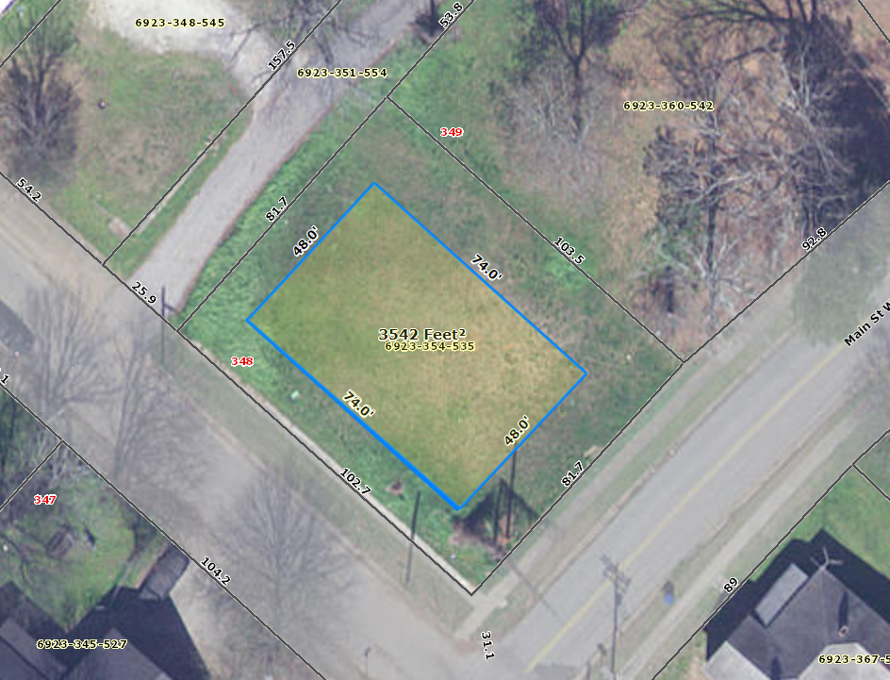

Schedule:
Event | Date
RFP Distribution | 04-19-23
Deadline for vendors to submit questions about the scope of work. | 04-26-23
Responses to vendors about scope. | 04-28-23
Proposal due date | 05-05-23
Sealed Bid Proposals are opened and voted on by the Ware Shoals Youth/ Community Activities Committee for a recommendation to full council. | 05-08-23
Project Completion Deadline | 07-08-23

Requirements:
- It is qualified to do business in the State of South Carolina and that it will take such action as, from time-to-time hereafter, may be necessary to remain so qualified.

- It is not in arrears with respect to payment of any monies due and owing the State of South Carolina, or any department of unit thereof, including but not limited to the payment of taxes and employee benefits, and that it shall not become so in arrears during the term of this contract;

- It shall comply with all Federal, State, and Local laws, regulations and ordinances applicable to its activities and obligations under this contract; and

- It shall obtain, at its expense, all licenses, permits, insurance, and governmental approvals, if any, necessary to the performance of its obligations under this contract, including but not limited to a Town of Ware Shoals Business license.

- Contractors are expected to be familiar with and comply with all Federal, State, and local laws, ordinances, codes, and regulations that may in any way affect the service offered. Ignorance on the part of the Contractor will in no way relieve it from responsibility for compliance.

INSURANCE REQUIREMENTS

The Contractor shall be required to maintain in force insurance as described below and approved by the Town Council for the duration of the Contract. Insurance coverage shall be a project specific or occurrence-based policy. Claims Made policies are acceptable for Professional Liability insurance only. Proof of acceptable insurance shall be required prior to Contract award, and shall be maintained in full force for duration of Contract. The policies shall stipulate that the insurance coverage shall not be changed or canceled unless the insured and the Town Administrator are notified in writing and approve the change not less than fifteen (15) days prior to such a change or cancellation. Town of Ware Shoals shall be named as an additional insured for Automobile Liability, Fire and Vandalism, and General Liability coverage. Town entity is not named as additional insured for Worker Compensation and Professional Liability coverage.

WORKER COMPENSATION INSURANCE
At a minimum, the Contractor shall carry the proper amount of Workmen's Compensation Insurance required under the laws of the State of South Carolina.

AUTOMOBILE LIABILITY INSURANCE
The Contractor shall purchase and maintain during the life of this Contract comprehensive automobile liability insurance in the amount of $1,000,000 per each occurrence for each vehicle used in any way to complete the Work.

COMPREHENSIVE GENERAL REQUIREMENTS
The Contractor shall purchase and maintain during the life of this Contract the following Comprehensive General Liability insurance:

A. $2,000,000.00 Annual Aggregate;
B. $1,000,000.00 per Occurrence;
C. $1,000,000.00 Products and Completed Operations;

Contract Award:
The contract will be awarded to the lowest responsible bidder. In addition to price The Town of Ware Shoals will consider
- The ability, capacity, and skill of the bidder
- if the bidder can perform the contract service promptly
- The character, integrity, reputation, judgment, experience, and efficiency of the bidder.
- The quality of performance of previous contracts or services.
- The sufficiency of the financial resources and ability of the bidder to perform the contract or provide the service
- The quality, availability, and adaptability of the supplies or contractual services to the particular use required.
- The ability of the bidder to provide future maintenance and services for the use of the subject of the contract.
- The number and scope of conditions attached to the bid.

RESERVATION OF RIGHTS

The Town reserves the right to reject any and all bids, to abandon the work entirely and to waive any informality or non-substantive irregularity as the interest of The Town may require and to be the sole judge of the selection process.

The Town retains the right at its sole discretion to select the contractor that is the lowest responsible bidder as defined in the State Statures or The Town ordinances, however the lowest proposed cost will not be the sole criterion for recommending the contract award.

The Town reserves the right to request any supplemental information it deems necessary to evaluate bidders experience or qualifications. This may include supplemental financial information, additional interview(s), and/or additional presentation by the bidder. Failure to furnish all information requested may disqualify the bidders, in the sole discretion of The Town. False, incomplete, misleading or unresponsive statements in a bid may also be sufficient cause for rejection.

The Town reserves the right to reconsider any proposal submitted at any stage of the procurement. It also reserves the right to meet with select bidders at any time to gather additional information.

The Town shall not be liable for any pre-contractual expenses incurred by prospective bidders or selected contractors, including but not limited to cost incurred in the preparation or submission of proposals. The Town shall be harmless and free from any and all liability, claims, or expenses whatsoever incurred by, or on behalf of, a person or organization responding to this invitation to bid.

If the successful bidder defaults, the Town may award the project to the next best proposal and my recover the loss occasioned by the successful bidder against a surety bond, if any, or by suit against the successful bidder.

All proposals submitted in response to this Invitation to Bid become the property of the Town and public records and, as such, may be subject to public review under the provisions of the Freedom of Information Act.

Bid Sheet
Project name: Concrete basketball court
 | Quantity | Unit Price | Amount
Rough/ fine grading of site, and addition of crush and run. |  |  | $
Pour and set 74x48 (3,352 sf) concrete pad with 1’’ slope. Pad 4’’ thickness. |  |  | $
Addition of Fiber mesh to pad. |  |  | $
Addition of wire mesh to pad. |  |  | $
Total:

Company: __________________________________________________________

Signature: __________________________________________________________

